PRESS RELEASE Karachi dated:16- September -2026
Subject. In compliance of the directions by the Secretary ECC&CD Department and Director General Sindh Environmental Protection Agency on Air Quality Index (AQI) of Karachi.
In Compliance of the directions issued by the worthy Secretary, Environment Climate Change & Coastal Development Department and Director General Sindh Environmental Protection Agency, regarding the monitoring of Karachi's Air Quality Index (AQI), VECOP filed team performed vehicular emissions activity along with Sindh Police at Malir District Malir karachi on 16th September 2026,
Details are given below:
Total No of Vehicle inspected – 20
Total No of vehicle passed – 18 (≤40% Opacity)
Total No of vehicle failed – 02(>40% Opacity)
Vehicle Make and Model - MAZDA AND HINO
Results of emissions – 60% to 80% (Opacity)

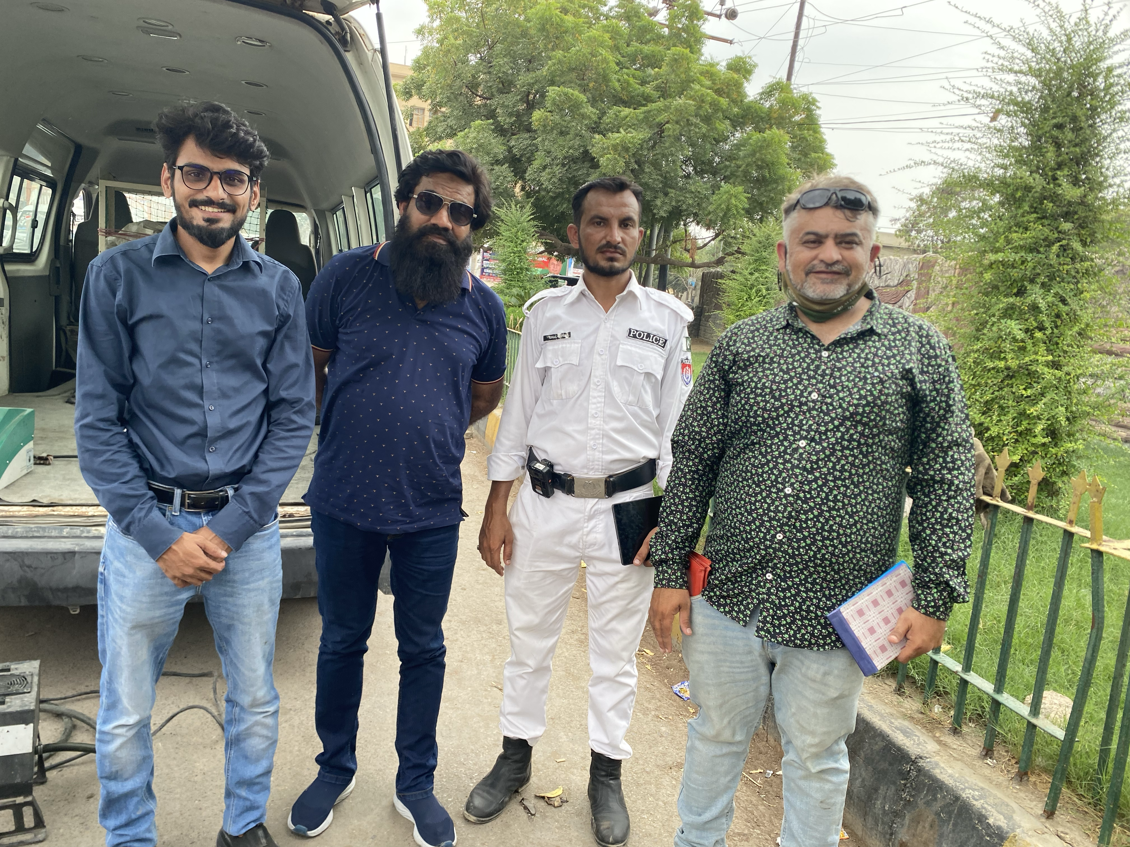 | 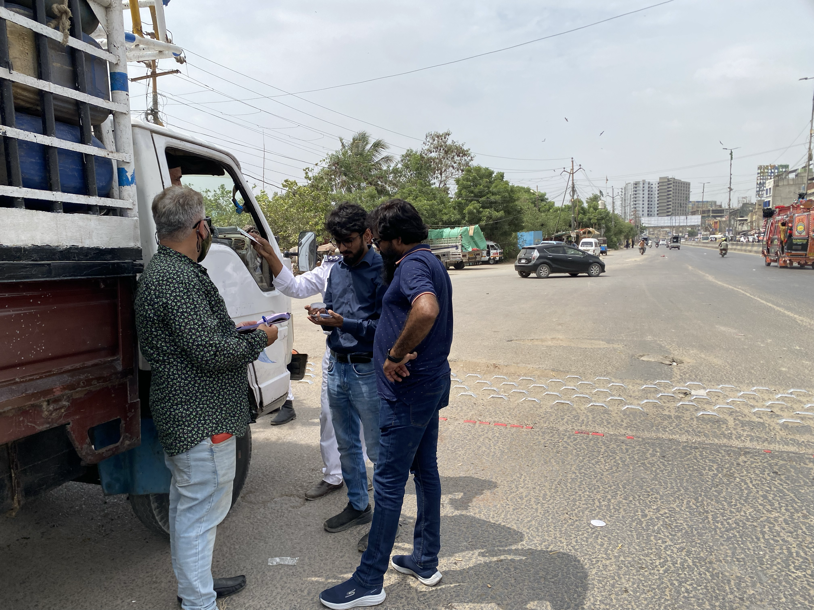
 | 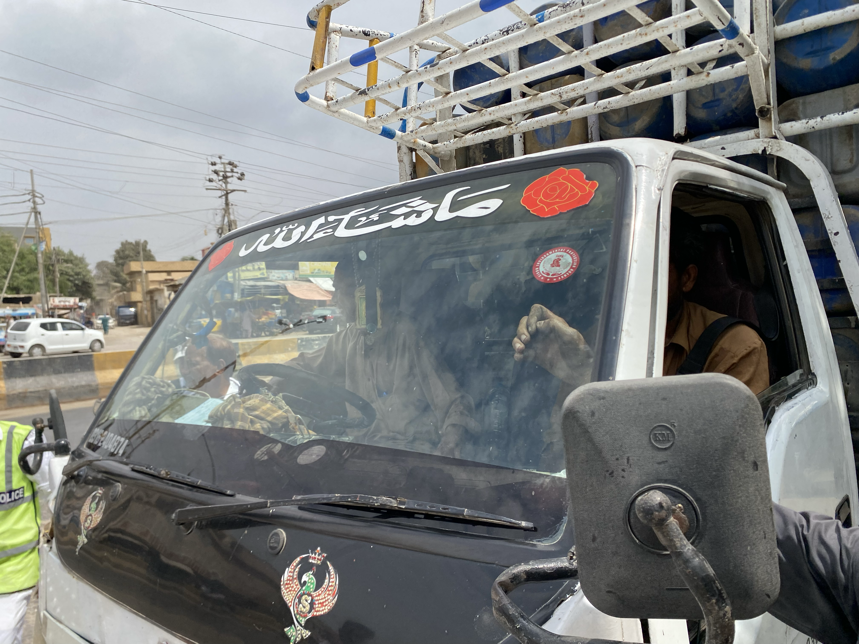

Abdul Rauf Memon
Director (Tech)/N. R
Incharge Vehicular Emission Control Program

