PRESS RELEASE Karachi dated:09th September 2026
Subject. In compliance of the directions by Secretary ECC&CD Department and Director General Sindh Environmental Protection Agency on Air Quality Index (AQI) of Karachi.
In Compliance of the directions issued by the Secretary, Environment Climate Change & Coastal Development Department and Director General Sindh Environmental Protection Agency, regarding the monitoring of Karachi's Air Quality Index (AQI), VECOP filed team performed vehicular emissions activity along with Sindh Police at Vita Chowrangi District Korangi on 10th September 2026,
Details are given below:
Total No of Vehicle inspected – 27
Total No of vehicle passed – 26(≤40% Opacity)
Total No of vehicle failed – 01 (>40% Opacity)
Vehicle Make and Model - MAZDA AND HINO
Results of emissions – 60% to 80% (Opacity)

 | 
 | 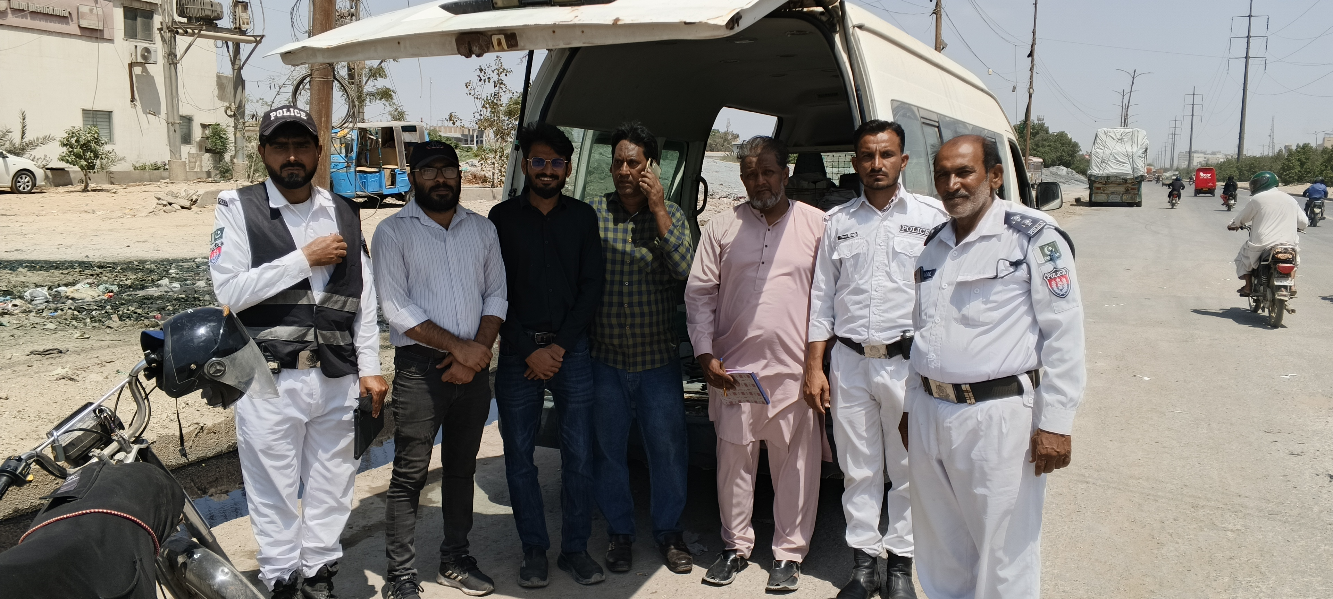

Abdul Rauf Memon
Director (Tech)/N. R
Incharge Vehicular Emission Control Program

